Artificial Intelligence Testing
Performance testing plan for AI-assisted incident features
Project: ServiceNow Incident Lifecycle Automation | Phase: Development - Performance Testing

1. Purpose and Scope
This plan verifies that AI-assisted features used in the incident process (such as suggested categorisation, assignment recommendation and similar-incident matching) respond quickly, scale with load and stay accurate as volume grows.
In scope:
- Response time and throughput of AI recommendation calls from the incident form and flows
- Accuracy of recommendations under normal and peak load
- Behaviour when the AI service is slow or unavailable
Out of scope:
- Training or retraining of models (see Machine Learning document)
- Platform-wide ServiceNow performance outside incident features

2. Test Objectives
- Confirm AI recommendations return within an acceptable time for the agent.
- Confirm accuracy does not degrade under concurrent use.
- Confirm the incident lifecycle continues normally when the AI service fails (graceful fallback).
- Identify the load level at which response times become unacceptable.

3. Test Scenarios and Targets
Targets below are proposed starting points. Confirm or replace them with agreed service levels before execution.
ID | Scenario | Metric | Proposed target
AI-01 | Single user requests a category suggestion on a new incident | Response time | 2 seconds or less
AI-02 | Many concurrent agents request recommendations (peak load) | Response time, error rate | 95th percentile within 4 seconds; errors under 1%
AI-03 | Similar-incident matching against a large incident history | Response time, match relevance | Within 3 seconds; top 3 results relevant
AI-04 | Sustained load over one hour | Stability, memory and latency drift | No degradation above 10%
AI-05 | AI service unavailable or timing out | Fallback behaviour | Incident can still be created and assigned manually
AI-06 | Accuracy check with a labelled sample under load | Recommendation accuracy | Within agreed margin of the baseline

4. Test Approach
- Define a baseline with a single user, then ramp load in steps (load test), then push beyond expected peak (stress test).
- Use a labelled sample of historical incidents to measure accuracy at each load step.
- Simulate service failure and timeouts to verify fallback behaviour and error messages.
- Record all runs with timestamp, load level and results for comparison.

5. Tools
Tool / area | Use
Load generator | JMeter, k6 or equivalent to drive concurrent requests
ServiceNow tools | Transaction logs, Performance dashboards, scripted REST calls
Evaluation | Spreadsheet or script comparing predictions with labelled outcomes

6. Test Data and Environment
- Use a non-production instance with data volumes similar to production.
- Use anonymised incident data; no personal data in test sets.
- Freeze configuration during each test run so results are comparable.

7. Entry and Exit Criteria
Type | Criteria
Entry | AI features configured and functionally tested; test instance and data ready; targets agreed.
Exit | All scenarios executed; targets met or exceptions approved; defects logged and triaged; results signed off.

8. Risks
Risk | Mitigation
Test instance is smaller than production | Scale results and state the assumption in the report
Labelled data is unrepresentative | Refresh the sample from recent incidents
External AI service rate limits distort results | Agree limits with the provider before testing

9. Results Log
ID | Scenario | Result | Pass / Fail | Notes

Process Diagram
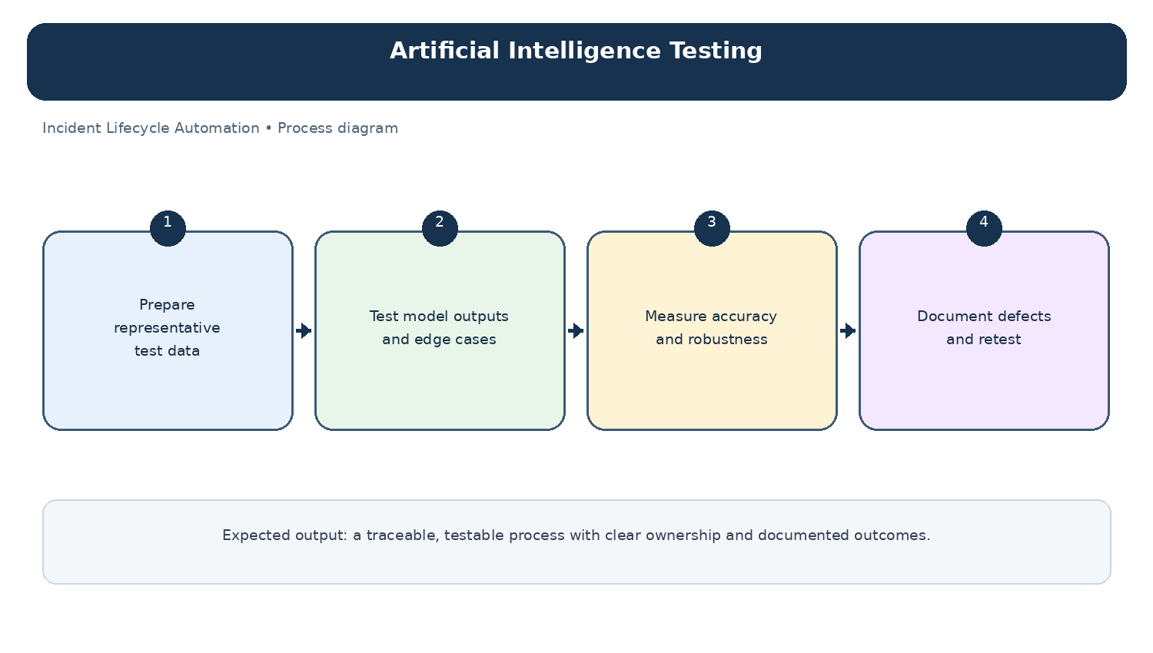
Diagram: Artificial Intelligence Testing — project-specific process overview.

